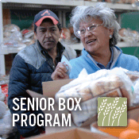
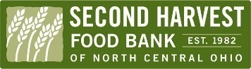
CSFP (Senior Box) Best Practices
Always ask ….
- Is the applicant over the age of 60?
- Do they meet income eligibility guidelines?
- Do they meet the residency criteria?
- Is the applicant receiving a senior box anywhere else?
Helpful tips…
- Every year all applicants will be required to fill out a new application. Income guidelines change yearly. Second Harvest will send out new forms and guidelines. Please keep current with your paperwork!
- Confirm address and phone numbers are current and working at time of intake just in case you need to call recipients with updates or changes to their CSFP box.
- If the recipient has a proxy please enter the proxy information. Authorized representatives are POA’s or anyone legally responsible. Proxy is most commonly a family member or neighbor.
- You must complete the entire application the same date. Once the application is processed fill out the client notification letter to inform the applicant of his or her status with your CSFP program. CSFP applications should be approved or denied by your program coordinator.
Before applicant leaves he or she should have all the following forms to take home:
- Notification letter
- Applicant Rights
- CSFP Proxy form (if requested)
- Written notice * Faith Based Organizations only *

Call Second Harvest, Program & Member Services staff with any questions, changes to your list, or to request assistance in recertifying your applications. 440.960.2265

